**Ideation Phase**

**Define the Problem Statements**

|  |  |
| --- | --- |
| **DATE** | 26th September 2022 |
| **TEAM ID** | PNT2022TMID27835 |
| **TEAM LEAD** | PAVITHRA M |
| **TEAM MEMBERS** | ABIRAMI P S  AMRITHA S  KIRTHIKA V |
| **PROJECT TITLE** | AIRLINE DATA ANALYTICS FOR AVIATION INDUSTRY |

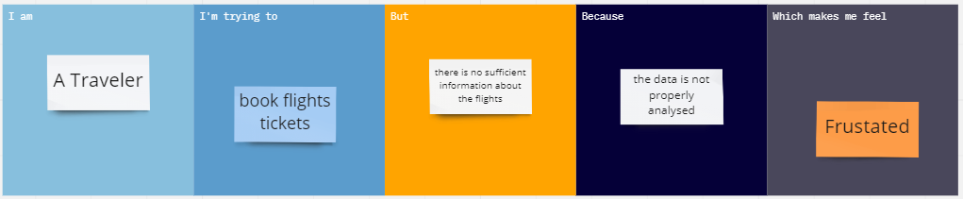

|  |  |  |  |  |  |
| --- | --- | --- | --- | --- | --- |
| **Problem**  **Statement (PS)** | **I am**  **(Customer)** | **I’m trying to** | **But** | **Because** | **Which makes me feel** |
| To provide better aviation services including easy ticket booking, seat selection, luggage, boarding by analyzing all the data required to capture various components of a passenger’s journey. | A Traveler | book flights tickets | there is no sufficient information about the flights | the data is not properly analysed | Frustated |